A PROJECT REPORT ON

**Single image haze/fog removal using dark channel prior and efficient fog removal from video in real-time**

Submitted To

INTEGRATED TEST RANGE

**submitted by SOUMAM BANERJEE**

**under the guidance of**

**Mr. Dipak Das, Sc-E, EOTS**



DEFENCE RESEARCH & DEVELOPMENT ORGANIZATION

INTEGRATED TEST RANGE, CHANDIPUR, BALASORE

#### Acknowledgements

I am thankful to my Project Head, Dipak Sir for guiding me throughout the project and helping me achieve the desired results as mentioned in the project. I also thank ITR, DRDO for providing me the opportunity to carry out the project of my choice.

**Soumam Banerjee**

**CONTENTS:**

1. Abstract
2. Introduction
3. Introduction to fog removal
4. Dark Channel Prior Based Dehazing
5. Analysis of DCP based dehazing
6. PROGRAM-1 (single image haze removal )
7. PROGRAM-2(video/real-time haze removal )
8. Results
9. System Requirements
10. Conclusion and future work
11. References

# **ABSTRACT:**

*This Report serves to implement algorithms to efficiently and accurately remove fog from single image as well as from real time.**In this study, a novel and efficient fog removal algorithm is used. Fog formation is because of attenuation and airlight. In this project, we have used a simple but effective image prior—****dark channel prior*** *to remove haze from a single input image. The dark channel prior is a kind of statistics of outdoor haze-free images. It is based on a key observation—most local patches in outdoor haze-free images contain some pixels whose intensity is very low in at least one color channel. Using this prior with the haze imaging model, we can directly estimate the thickness of the haze and recover a high-quality haze-free image. Results on a variety of hazy images demonstrate the power of the proposed prior. Moreover, a high-quality depth map can also be obtained as a byproduct of haze removal.*

*Our Second aim is to convert the above result even for the video as well as for the real time system , which demanded a very fast computing algorithm for the single image fog removal system as we need to compute it for each and every frame of the video.*

*Simulation results has also been attached at the end to show our performance output. This algorithm has a wide application in tracking and navigation, consumer electronics and entertainment industries.*

Index Terms—*Dehaze, defog, image restoration, depth estimation, image enhancement, fog removal,attenuation , airlight , atmospheric visibility , outdoor vision*

# **INTRODUCTION:**

Image processing is the process of working with a digitized image to find solutions to a particular problem or to change the view of image to suit the needs of a user.

In this process, generally, we make use of the grayscale Image to carry out the processing. In a colour Image, each pixel of the Image is comprised of three parts, the ratio of Red, Green and Blue colours. For example in an Image with a single pixel definition as (120,145,225), this would signify that there is 120 parts of Red, 145 parts of Green and 225 parts of Blue in that pixel which gives that pixel its constituent color. All parts are measured in a scale of 0 to 255 where 0 signifies absence and 255 represents complete presence of the mentioned colour.   
For any image, it is defined to be of a specific pixel ratio such as 1600:1200 or 1980:1080 or 640:480 etc. This would mean that the digitized image can be expressed in the form of a matrix where number of rows signifies the first part of the ratio and the second part of the ratio determines the number of columns. Each element in that matrix signifies each pixel definition which is given as a set of 3 numbers in a RGB Image, signifying Red, Green and Blue ratios respectively. The whole matrix would hence represent complete information of the specific positions of the pixels and also the properties of each pixel in the image, which when converted to the image form, would give us the whole desired image. Image processing is the change of such properties using some mathematical calculations on the Image matrix to provide desired output to the user.   
In our experiment and project, we would convert a RGB image to its grayscale form, the use being the fact that each element of the Image Matrix would comprise of a single number ranging from 0 to 255, where 0 would represent black and 255 represents white and the numbers in between would represent the shades of gray from blackish to whitish as the number increases from 0 to 255, both exclusive. The processing on such numbers would hence provide us our desired result after converting the matrix back to the image form.   
Through the report, we shall proceed from basic Image Processing to the fog/removal algorithm that we have worked on as well as few others and we shall also prove why our chosen algorithm is better with respect to the others.

First let us examine the programming languages being used for our purpose:

1. **Python**

Python is a simple, easy to use open source coding platform, using simple English language commands to implement the desired operations of the user. Python is also very easily implementable in Raspberry Pi systems, which is a major factor for our selection of this programming language. It also implements very small block of code and is easily interpreted by the compiler with respect to other programming languages like Java and C++.  
For example, in Java, to print “Hello World”:

class hello  
{  
 public static void main(String args[])  
 {  
 System.out.println(“Hello World”);  
 }  
}

For C++, we would have something like  
class hello  
{  
 int main()  
 {  
 cout>> “Hello World” >>endl;  
 }  
}

But in Python, this is easily done by the command:  
print (“Hello World”)  
Hence, we observe the extensive use of python for easy programming, by use of easy syntaxes and also reducing the amount of code and hence file sizes.

1. **OpenCV**

Open CV is also an open source platform that can be embedded into any coding language. This open source platform makes calculations and processing of data easier by the use of library files. In our programs, we shall implement “Numpy” to carry our processes on our Image Matrices and Open CV to read and write Video Frames and Images easily. Open CV is a source library platform which contains huge libraries to work on. Commands like imread(), imwrite(), imshow(), VideoCapture(), and many others help us to easily capture the frame of a video from an existing camera or input video. Implementing OpenCV with python is an easy method where we just have to import the required files we want to work on with and implement the commands in our code. As we proceed further with our processes, we shall explain how opencv has served as an useful tool along with python to provide us an easy way to opening and reading frames and images.

# **1.1 Introduction to Fog Removal:**

Due to absorption and scattering by atmospheric particles in haze, outdoor images have poor visibility under inclement weather. Poor visibility negatively impacts not only consumer photography but also computer vision applications for outdoor environments, such as object detection and video surveillance. Haze removal, which is referred to as dehazing, is considered an important process because haze-free images are visually pleasing and can significantly improve the performance of computer vision tasks.

Methods presented in earlier studies had required multiple images to perform dehazing. For example, polarization-based methods use the polarization property of scattered light to restore the scene depth information from two or more images taken with different degrees of polarization. Similarly, in multiple images of the same scene are captured under different weather conditions to be used as reference images with clear weather conditions. However, these methods with multiple reference images have limitation in online image dehazing applications and may need a special imaging sensor. This leads the researchers to focus the dehazing method with a single reference image. Single image based methods rely on the typical characteristics of haze-free images. Tan proposed a method that takes into account the characteristic that a haze-free image has a higher contrast than a hazy image. By maximizing the local contrast of the input hazy image, it enhances the visibility but introduces blocking artifacts around depth discontinuities. Fattal proposed a method that infers the medium transmission by estimating the albedo of the scene. The underlying assumption is that the transmission and surface shading are locally uncorrected, which does not hold under a dense haze.

Observing the property of haze-free outdoor images, **He** proposed a novel prior—***dark channel prior*** (DCP). The DCP is based on the property of “**dark pixels**,” which have a very low intensity in at least one color channel, except for the sky region. Owing to its effectiveness in dehazing, the majority of recent dehazing techniques have adopted the DCP. The DCP-based dehazing techniques are composed of four major steps: atmospheric light estimation, transmission map estimation, transmission map refinement, and image reconstruction. In this report, we perform an in-depth analysis of the DCP-based methods in the four-step point of view.

The rest of the report is organized as follows. In Section 1.2 , the original DCP-based dehazing method is first reviewed. Section 1.3 provides an in-depth survey of conventional DCP-based methods. Relevant programs are attached with the following report and at last the summary, results, system requirements, conclusion and future works are given.

# **1.2 Dark channel prior based image dehazing**

#### **1.2.1 Degradation model** A hazy image formed as shown in Fig. 1 can be mathematically modeled as follows

|  |
| --- |
| (1)    **Fig. 1 Formation of a hazy image**  where *x* represents the image coordinates, *I* is the observed hazy image, *J* is the haze-free image, *A* is the global atmospheric light, *β* is the scattering coefficient of the atmosphere, and *d* is the scene depth. Here, *e* −*βd* is often represented as the transmission map and is given by  (2)  In clear weather conditions, we have *β* ≈ 0, and thus *I* ≈ *J*. However, *β* becomes non-negligible for hazy images. The first term of Eq. (1), *J*(*x*)*t*(*x*) (*the direct attenuation*), decreases as the scene depth increases. In contrast, the second term of Eq. (1), *A*(1 − *t*(*x*)) (*the airlight*), increases as the scene depth increases. Since the goal of image dehazing is to recover *J* from *I*, once *A* and *t* are estimated from *I*, *J* can be arithmetically obtained as given below in equation (3) |

|  |
| --- |
|  |

(3)

However, the estimation of *A* and *t* is non-trivial. In particular, since *t* varies spatially according to the scene depth, the number of unknowns is equivalent to the number of image pixels. Thus, a direct estimation of *t* from *I* is prohibitive without any prior knowledge or assumptions.

#### 1.2.2 Dark channel prior (DCP)

# He *et al*. performed an empirical investigation of the characteristic of haze-free outdoor images. They found that there are dark pixels whose intensity values are very close to zero for at least one color channel within an image patch. Based on this observation, a dark channel is defined as follows:

|  |
| --- |
| (4) |

where *J**c* is an intensity for a color channel *c* ∈ {*r*, *g*, *b*} of the RGB image and *Ω*(*x*) is a local patch centered at pixel *x*. According to Eq. (4), the minimum value among the three color channels and all pixels in *Ω*(*x*) is chosen as the dark channel *J* dark(*x*).

From 5000 dark channels of outdoor haze-free images, it was demonstrated that about 75 percent of the pixels in the dark channels have zero values and 90 percent of the pixels have values below 35 when the pixels in the sky region are excluded . The low intensities in the dark channel are due to the following three main features: (i) shadows, e.g., shadows from cars and buildings in an urban scene or shadows from trees, leaves, and rocks in a landscape (ii) colorful objects or surfaces, e.g., red or yellow flowers and leaves and (iii) dark objects or surfaces, e.g., dark tree trunks and stones . Based on the above observation, the pixel value at the dark channel can be approximated as follows:

Jdark≈0 (5)

This approximation to zero for the pixel value of the dark channel is called the DCP.

On the contrary, the dark channels from hazy images produce pixels that have values far above zero . Global atmospheric light tends to be achromatic and bright, and a mixture of airlight and direct attenuation significantly increases the minimum value of the three color channels in the local patch. This implies that the pixel values of the dark channel can serve as an important clue to estimate the haze density. Successful dehazing results of various DCP-based dehazing algorithms support the effectiveness of the DCP in image dehazing.

#### 1.2.3 DCP-based image dehazing

In the DCP-based dehazing algorithm , the dark channel is first constructed from the input image as in Eq. ([4](https://link.springer.com/article/10.1186/s13640-016-0104-y#Equ4)). The atmospheric light and the transmission map are then obtained from the dark channel. The transmission map is further refined, and the haze-free image is finally reconstructed as Eq. ([3](https://link.springer.com/article/10.1186/s13640-016-0104-y#Equ3)).

More specifically, given the degradation model of

|  |
| --- |
| (6) |

the minimum intensity in the local patch of each color channel is taken after dividing both sides of Eq. ([6](https://link.springer.com/article/10.1186/s13640-016-0104-y#Equ6)) by ${A^{c}}^{}$ as follows:

|  |
| --- |
| (7) |

Here the transmission in the local patch *Ω*(*x*) is assumed to be constant and is represented as 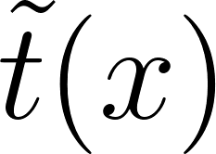 [7]. Then, the min operator of the three color channels can be applied to Eq. (7) as follows:

|  |
| --- |
| (8) |

According to the DCP approximation of Eq. (5),  can be represented as

|  |
| --- |
| (9) |

Here, the atmospheric light *A* needs to be estimated in order to obtain the transmission map  . Most of the previous single image based dehazing methods estimate *A* from the most haze-opaque pixels. As discussed in Section 1.2.2, the pixel value of the dark channel is highly correlated with haze density. Therefore, the top 0.1 % of the brightest pixels in the dark channel is first selected, and the color with the highest intensity value among the selected pixels is then used as the value for *A* [7].Figure 2 illustrates the process used to obtain *A*. If the pixel with the highest intensity value is used to estimate *A*, the pixels in the patches as shown in Fig. 2d, e would be selected, yielding significant estimation errors. Instead, by finding the candidate pixels from the dark channel as shown in Fig. 2b, the pixel that accurately estimates *A* can be found as shown in Fig. 2c.

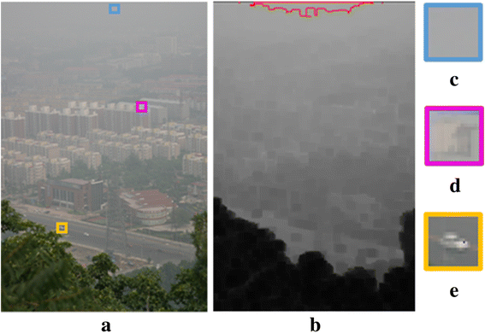

Fig. 2 Estimation of the atmospheric light [9]. a Hazy image. b Dark channel, where the size of *Ω* is 15 × 15 and the region inside the *red boundary lines* corresponds to the most haze-opaque region. c Patch used to determine the atmospheric light. d, e Patches that contain intensity values higher than that of the atmospheric light.

It is noted in [7] that the DCP is not reliable in the sky region. Fortunately, the color of the sky is close to *A* in hazy images, and thus, we have

|  |
| --- |
| (10) |

This corresponds to the definition of *t*(*x*) because *d*(*x*) approaches infinity for the sky region. Therefore, the sky does not need special treatment for estimating the transmission map if we obtain as Eq. (9). Given *A*,  , and *I*, the dehazed image is obtained as

|  |
| --- |
| (11) |

where *t0* is used as a lower bound for the transmission map.

# **1.3 Analysis of DCP-based dehazing algorithms**

In Section 1.2, we reviewed the original DCP-based dehazing algorithm [9]. The follow-up methods are based on the basic structure presented in [9] but differ in each step of the dehazing procedure. Instead of analyzing each method individually, we classify all the methods in accordance with the four steps of image dehazing and then perform a step-by-step analysis. Each of the following subsections describes and compares the various methods used for each step.

#### 1.3.1 Dark channel construction

Most conventional DCP-based dehazing methods estimate the dark channel from the input hazy image *I*. In Eq. ([4](https://link.springer.com/article/10.1186/s13640-016-0104-y#Equ4)), the size of the local patch *Ω*(*x*) is the only parameter that needs to be determined. Although the effect of the size of the local patch is significant, most conventional methods simply use a local patch with a fixed size or do not specify the size of the local patch. Table [2](https://link.springer.com/article/10.1186/s13640-016-0104-y#Tab2) shows typical patch sizes used in the previous methods.

Table 1

Comparison of DCP-based dehazing algorithms

|  |  |  |
| --- | --- | --- |
| **Step** | **Method** | |
| Dark channel construction | Min filter (Eq. (4)) | |
| Median filter (Eq. (12)) | |
| Atmospheric light estimation | Candidate | DCP top 0.1 % |
| DCP top 0.2% |
| DCP maximum |
| DCP top 5 % and edge |
| Selection criterion | Intensity |
| Entropy |
| Transmission map construction | Eq. (17) | |
| Eq. (18) | |
| (i) | |
| Transmission map refinement | Gaussian filter | |
| Bilateral filter | |
| Soft matting | |
| Cross-bilateral filter | |
| Guided filter | |

# Table 2: Local patch sizes used for previous methods

|  |
| --- |
| **Patch size** |
| 3 × 3 |
| 11 × 11 |
| 15 × 15 |

# Figure 3a shows two hazy images. The top row in Fig. 3 corresponds to a remote aerial photograph with less local texture and heavy haze. Therefore, a small local patch is sufficient in order to estimate the dark channel, resulting in a reduction in the DCP calculation time. However, an image that has complicated local textures, as shown in the second row of Fig. 3, needs a larger local patch size to exclude false textures from the dark channel. Note that the block-min process of Eq. (4) inevitably decreases the apparent resolution of the dark channel as the size of the patch increases. Therefore, the minimum possible patch size that does not produce false textures in the dark channel needs to be found for every hazy image by considering application-dependent image local details.

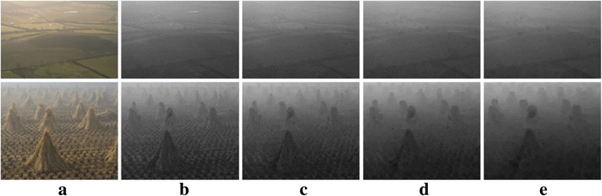

**Fig. 3**

**Dark channels of various patch size obtained by Eq. (**[**4**](https://link.springer.com/article/10.1186/s13640-016-0104-y#Equ4)**). a Hazy image. Dark channels obtained by Eq. (**[**4**](https://link.springer.com/article/10.1186/s13640-016-0104-y#Equ4)**) with the patch size of (b) 3 × 3, (c) 7 × 7, (d) 11 × 11, and (e) 15 × 15**

Apart from the aforementioned general method for the dark channel estimation, Zhang replaced the minimum operator by the median operator as follows:

|  |
| --- |
| (12) |

#### 1.3.2 Atmospheric light estimation

The majority of conventional DCP-based dehazing methods estimate *A* as described in Section [1.2.3](https://link.springer.com/article/10.1186/s13640-016-0104-y#Sec6). In [6], the pixel with the highest dark channel value is used directly as follows:

|  |
| --- |
| (13) |

**I have also done the same to reduce the computational time complexity.** However, the above method can incorrectly select the pixel when the scene contains bright objects (which is a bit rare ). Instead, pixels with a top *p*% dark channel values are selected as the most haze-opaque pixels, and the one with the highest intensity is used to estimate *A*. This remains one parameter p in the estimation of *A*, which is empirically set as 0.1

#### 1.3.3 Transmission map estimation

|  |
| --- |
| The transmission map  fined in Eq. ([9](https://link.springer.com/article/10.1186/s13640-016-0104-y#Equ9)) is obtained from the DCP. If the DCP is not exploited, Eq. ([9](https://link.springer.com/article/10.1186/s13640-016-0104-y#Equ9)) can be rewritten as |

|  |
| --- |
| (16) |

As we observed in Section [1.2.2](https://link.springer.com/article/10.1186/s13640-016-0104-y#Sec5), the pixel value of the dark channel, *J* dark(*x*), is highly likely zero, and so is (*J*/*A*)dark(*x*). However, if (*J*/*A*)dark(*x*) is not close to zero, the transmission map obtained as Eq. ([9](https://link.springer.com/article/10.1186/s13640-016-0104-y#Equ9)) can be underestimated since the positive offset in Eq. ([16](https://link.springer.com/article/10.1186/s13640-016-0104-y#Equ16)) is always neglected .

In the original DCP-based dehazing method, it is mentioned that the image may look unnatural if the haze is removed thoroughly [[10](https://link.springer.com/article/10.1186/s13640-016-0104-y#CR10)]. A constant *ω* (0 < *ω* < 1) is thus used to retain a small amount of haze [5] :

|  |
| --- |
| (17) |

However, we consider that a better visibility in the dehazed image can be achieved with Eq. ([17](https://link.springer.com/article/10.1186/s13640-016-0104-y#Equ17)) because we inadvertently compensate for the under-estimation of  by multiplying *ω*.

Xu *et al.* [8] explicitly addressed the aforementioned under-estimation problem of the transmission map and simply added a positive value *ρ* ∈ [0.08, 0.25] to the transmission map:

|  |
| --- |
| (18) |

#### 

#### 1.3.4 Transmission map refinement

Incorrect estimation for the transmission map can lead to some problems such as false textures and blocking artifacts. In particular, the block-min process of Eq. (4) decreases the apparent resolution of the dark channel, resulting in blurry transmission maps. For this reason, many methods have been developed to further sharpen the transmission map. Many dehazing methods differ in the way of smoothing the transmission map. Post-filtering methods are used to improve the accuracy of the transmission map. Some filtering methods, such as the Gaussian and bilateral filters, use only transmission maps, whereas the other methods, such as soft matting, cross-bilateral filter, and guided filter, exploit a hazy color image as a guidance signal. Each method and its performance are analyzed in the following subsections.

#### 1.3.5 Dehazed image construction

After estimating the atmospheric light *Â* and transmission map , the de-hazed image *J* can be readily obtained from the degradation model as Eq. (6). Specifically, *J* is given as

|  |
| --- |
| (19) |

where *t0* is a typical value for avoiding a low value of the denominator [6]. Most DCP-based dehazing methods used *t*0 as 0.1 Figure 4 shows the dehazed images obtained using the top three transmission map refinement methods. As can be seen, the reconstruction of *J* by Eq. (19) can yield visually pleasant dehazed images.

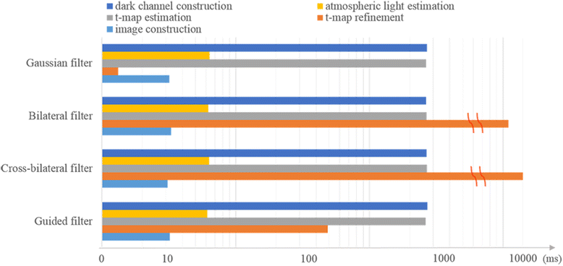

Fig. 4

Comparison of time consumption for each dehazing step with different transmission map refinement methods [6]

When the hazy image contains significant color distortion by abnormal climate such as sandstorm, the estimated atmospheric light *Â* becomes far from achromatic, and thus, color correction is required at the dehazed image reconstruction. In such a case, *J* is obtained as follows [6]:

|  |
| --- |
| (29) |

where the superscript *c* represents the color channel, *c* ∈ {*r*, *g*, *b*}, and *d* *c* denotes the difference between the average values of the red and *c* channels of *I*. In other words, the offset in the red channel caused by sandstorm is subtracted before the construction of the de-hazed image.

# THE PROGRAM (Single-Image)

# 

# 

# 

# THE PROGRAM (Video/Real-Time)

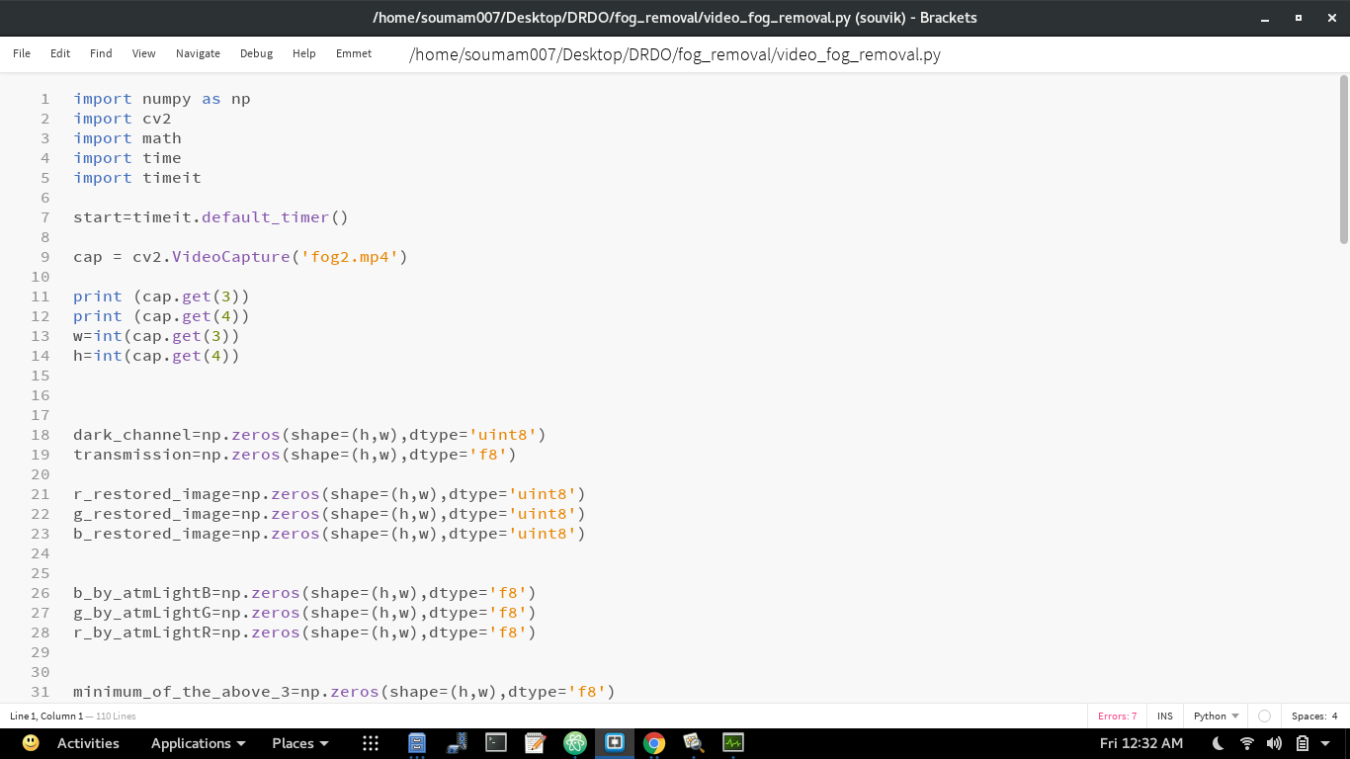

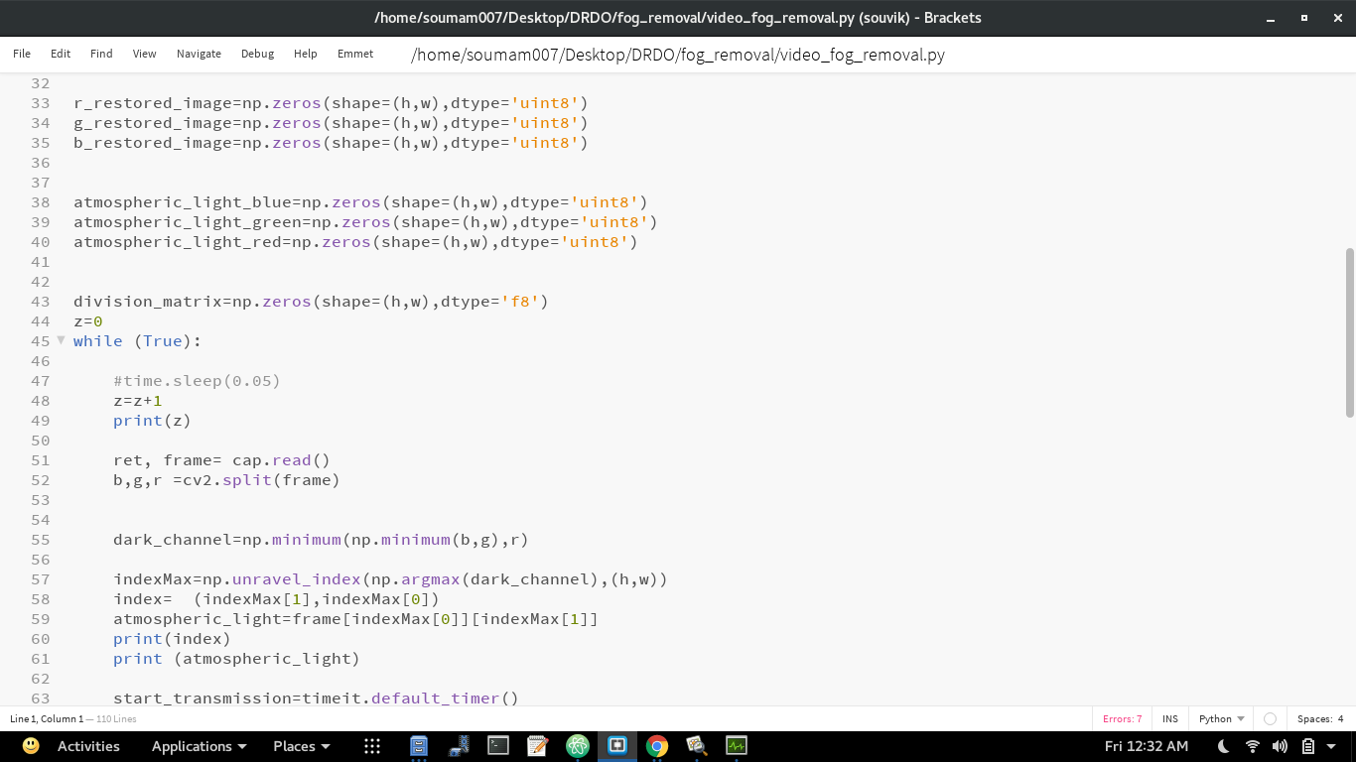

# 

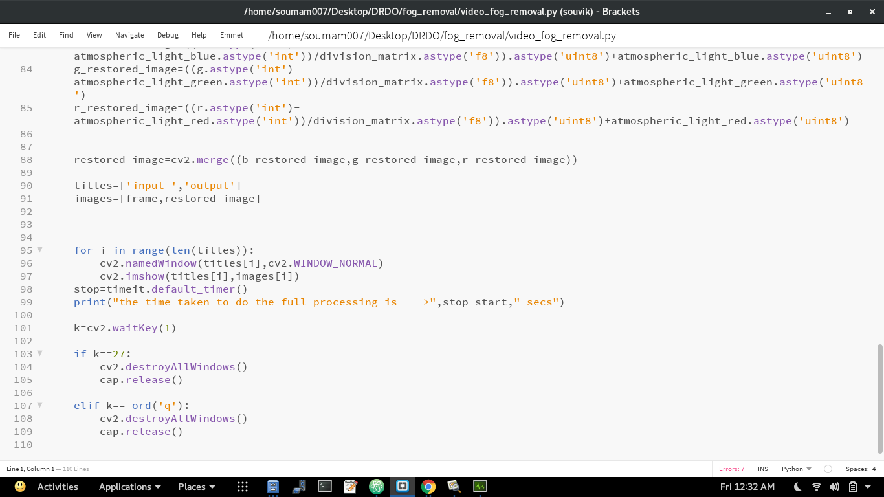

Note:-

Most DCP-based dehazing methods used ***t*0** as **0.1** but I have used **t0** as **0.6** as per my experiment output and value of **⍵** used is **0.95**

# **SUMMARY :**

In this report , we performed an in-depth survey on DCP-based image dehazing methods. Especially, we classified relevant research articles related to the DCP according to the four steps and performed a step-by-step analysis. Our findings can be summarized as follows.

* ***Dark channel construction*:** the local patch size is a very important parameter for dark channel construction. Color textures are transferred to the dark channel when a small local patch is used, whereas blurry dark channels are obtained when a large local patch is used. In addition, a physically less meaningful median filter is found to be not very effective in dark channel construction.
* ***Atmospheric light estimation*:** the atmospheric light is reliably estimated from the dark channel, especially when the dark channel is obtained using a large local patch. Therefore, if the local patch size used in dark channel construction is not large enough, it is recommended to use an additional dark channel with a larger local patch size only for atmospheric light estimation. The use of local entropy is also found to be effective in enhancing the estimation accuracy because atmospheric light estimation from bright objects can be prevented.
* ***Transmission map estimation*:** the under-estimation problem of the transmission map is addressed. The conventional gain and offset control methods are examined, but an adaptive correction scheme is found to be necessary for precise estimation of the transmission map, which is missing in the current literature.
* ***Transmission map refinement*:** the performance of transmission map refinement is improved when a hazy image is used as a guidance image. The soft matting method shows the best transmission map estimation accuracy, and the guided and cross-bilateral filters show the second-best accuracy. The Gaussian and guided filters perform best in terms of the computational complexity, but the guided filter is most memory-inefficient among the five investigated refinement schemes.We have used Bilateral Filter for transmission map refinement (when needed)
* ***Restoring the haze free image*:** finally the haze free image is restored by our desired equation as mentioned above.

**Results**

**Fog removal from single image**

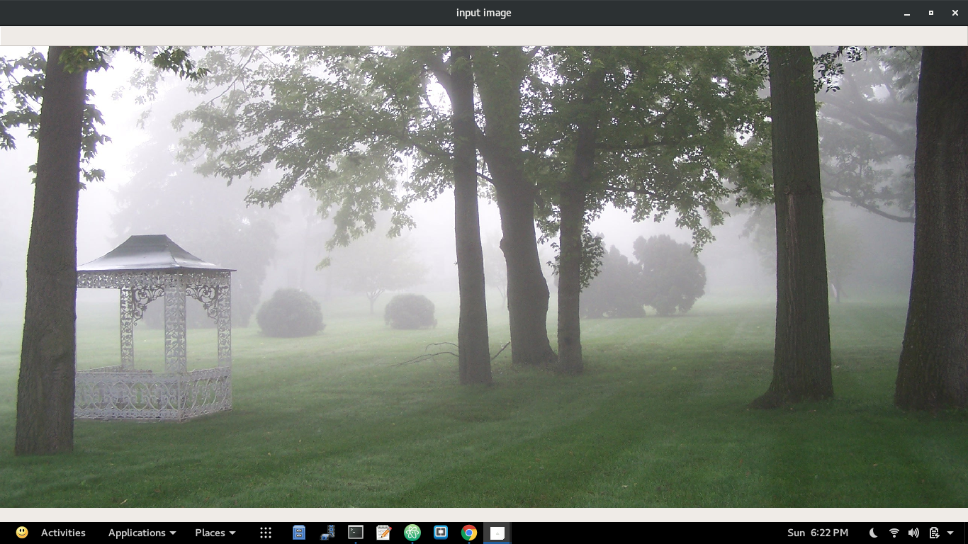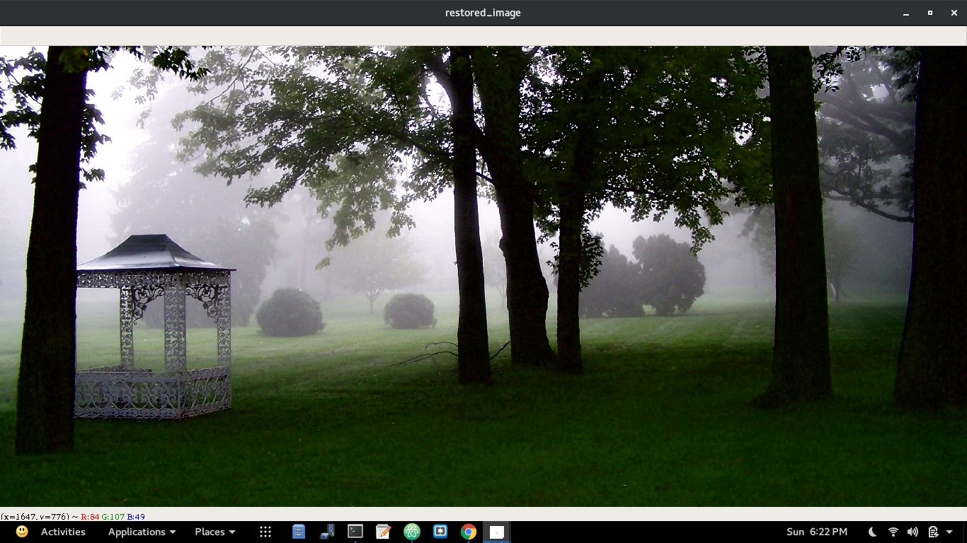

**1.a Input Image of pic 1 1.b Output image of pic 1**

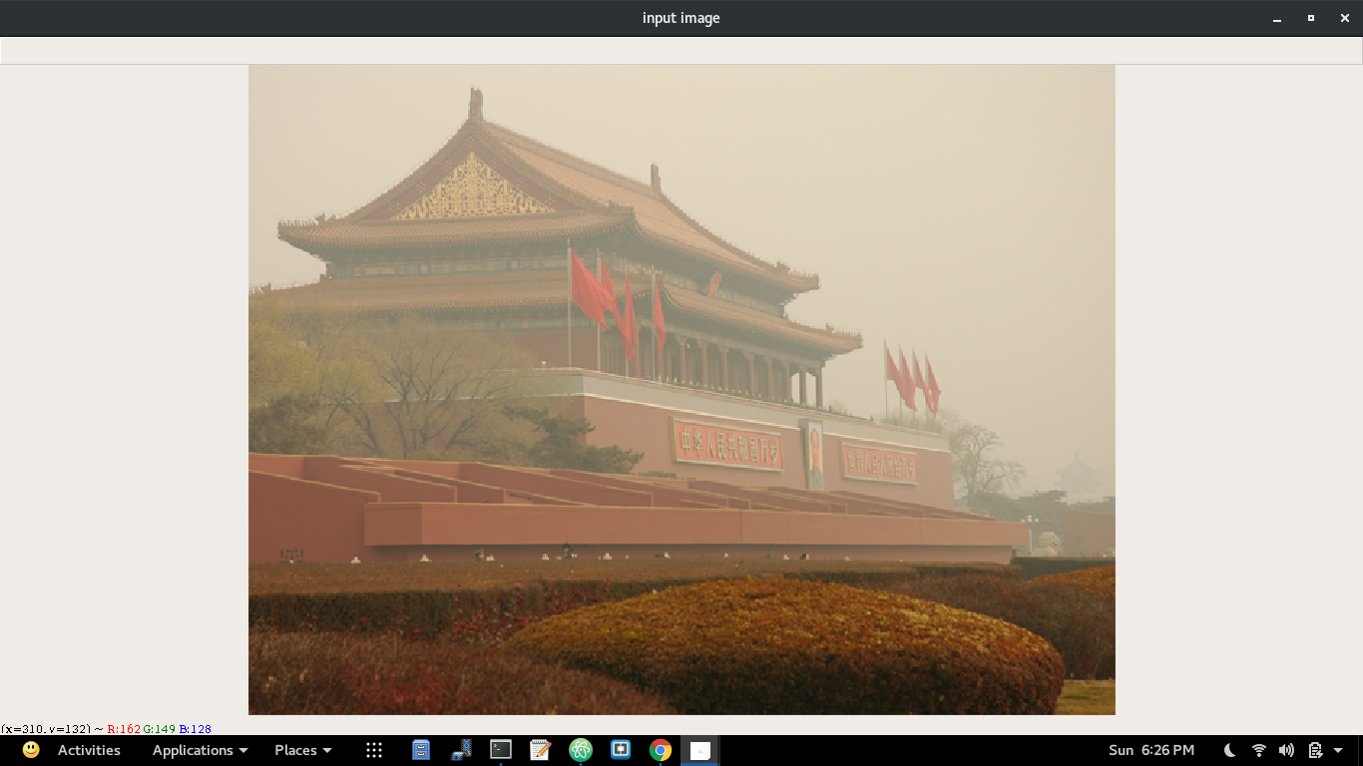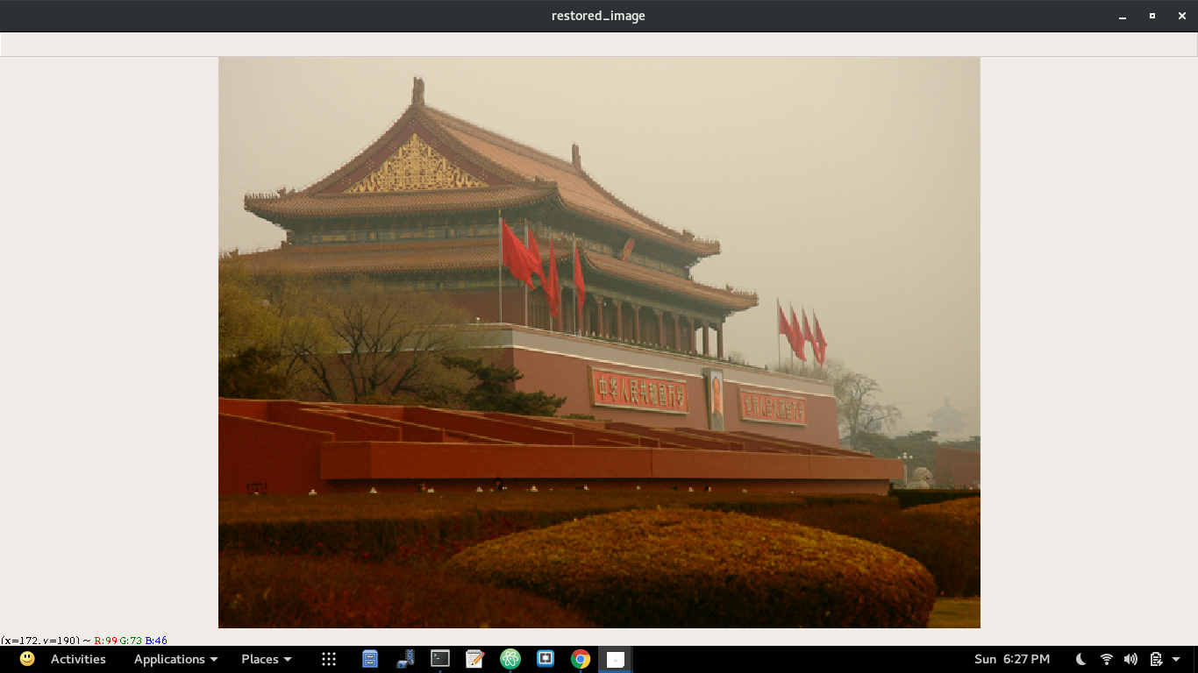

**2.a Input Image of pic 2 2.b Output Image of pic 2**

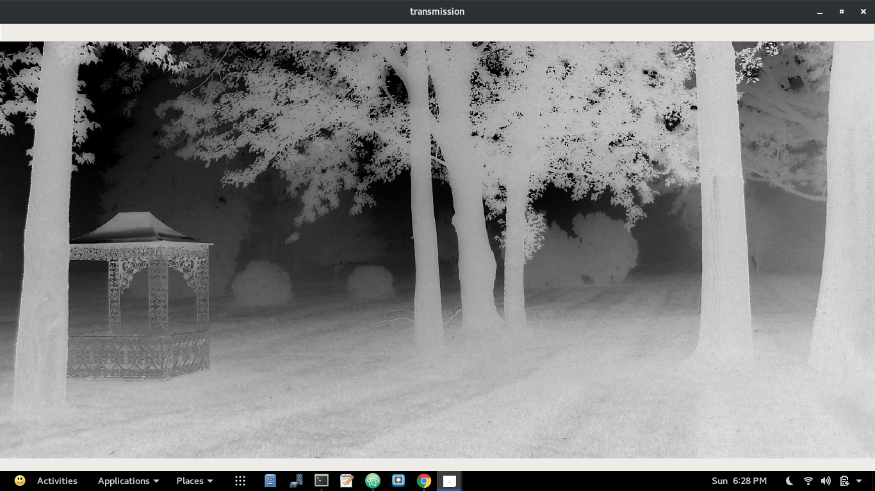 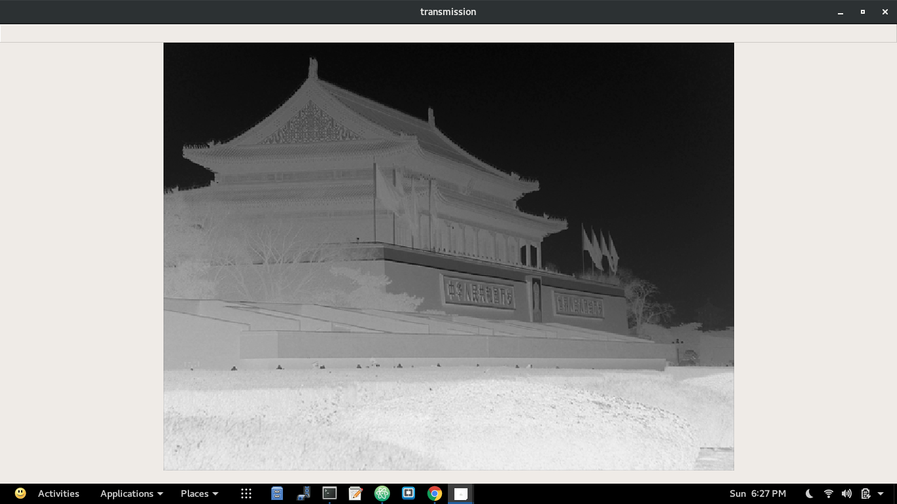

**3.a Transmission Map of pic 1 3.b Transmission Map of pic 2**

**Fog removal from video/real-time video**

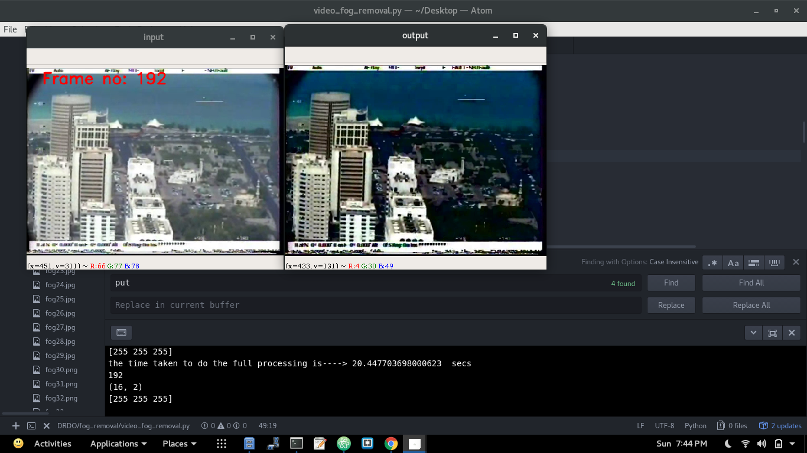

**Input and output of ‘fog_video_1.mp4’ (Frame no:- 192)**

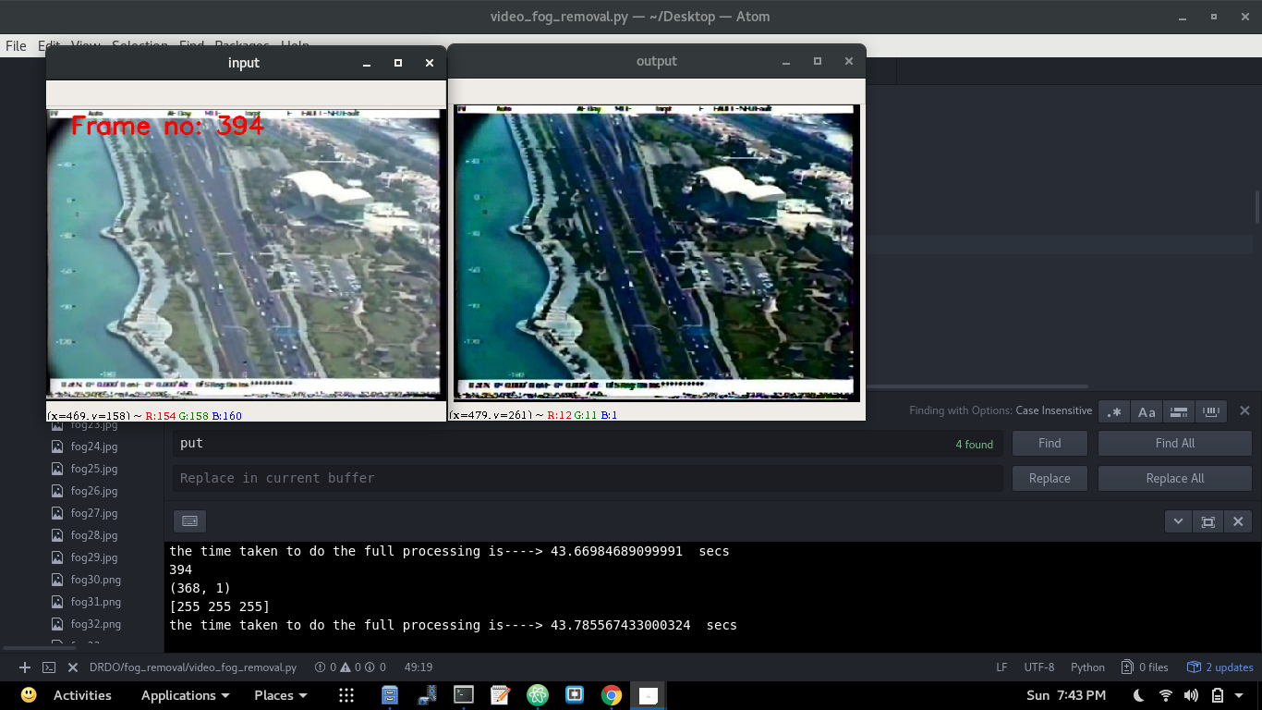

**Input and output of ‘fog_video_1.mp4’ (Frame no:- 394)**

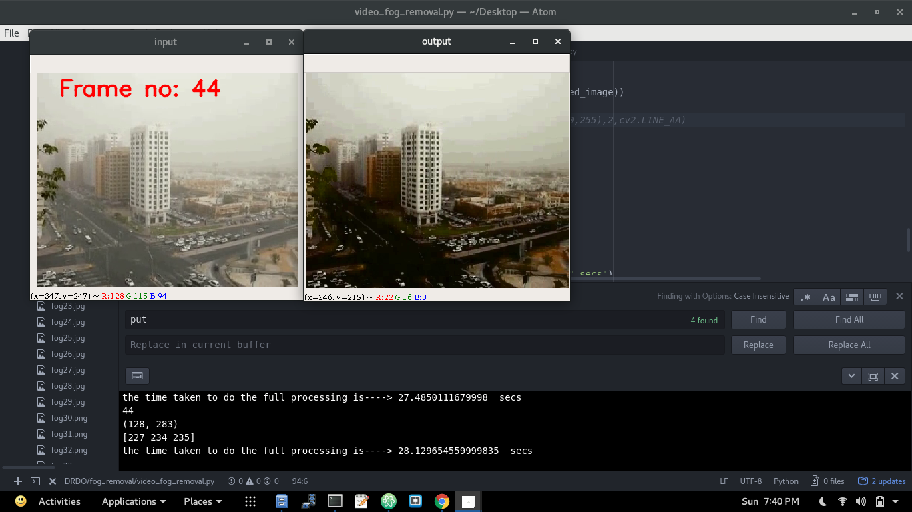

**Input and output of ‘fog_video_2.mp4’ (Frame no:- 44)**

**SYSTEM REQUIREMENTS:**

Simulation of proposed fog removal algorithm is carried out in various foggy imagesAll simulations have been done in Python3.6.5 environment and openCV 3.4.0 and complex matrix Calculations have been done using Numpy which lead to the reduction of processing time to a much extent.

Configuration of my systems are as follows:-

Operating System-> Fedora 26(linux-based) 64-bit ,

RAM-> 8GB ,

Processor-> Intel® Core™ i5-6200U CPU @ 2.30GHz × 4

# **CONCLUSION AND FUTURE WORK:**

Throughout our project we have seen how we can effectively and efficiently remove the fog from single image as well as from videos/real-time videos.We performed an in-depth study as well as practically implemented on one of the most successful dehazing algorithms: the DCP-based image dehazing algorithm. Considering the four major steps of the DCP-based image dehazing, which are atmospheric light estimation, transmission map estimation, transmission map refinement, and image reconstruction, we classified recent research articles related to the DCP according to these four steps and performed a step-by-step analysis of conventional methods. Moreover, the conventional methods developed for evaluating the performance of image dehazing were also summarized and discussed.

In our course, we have taken certain assumptions and performed our work, which has provided desirable outputs. There is a lot of future work in this area still left to be done to improve the results in question and also develop better algorithms to provide accurate end values.

It can be safely concluded about our work that we have formed a basis and opening for future work in this field of using template matching as a basic idea to give a detailed view and perspective of our desired objective.

# **References**

1. Digital Image Processing – R. Gonzales
2. OpenCV 3.4.1 Documentation
3. https:\www.stackoverflow.com
4. Python 3.6 Documentation
5. Lee, S., Yun, S., Nam, JH. et al. J Image Video Proc. (2016) 2016: 4. <https://doi.org/10.1186/s13640-016-0104-y>
6. A. K. Tripathi and S. Mukhopadhyay, "Single image fog removal using bilateral filter," *2012 IEEE International Conference on Signal Processing, Computing and Control*, Waknaghat Solan, 2012, pp. 1-6.
7. K He, J Sun, X Tang, *Proceedings of IEEE Computer Society Conference on Computer Vision and Pattern Recognition* (CVPR, Miami, 2009), pp. 1956–1963
8. H Xu, J Guo, Q Liu, L Ye, Fast image dehazing using improved dark channel prior, in *Proceedings of International Conference on Information Science and Technology* (ICIST, Hubei, 2012), pp. 663–667
9. K He, J Sun, X Tang, *Proceedings of IEEE Computer Society Conference on Computer Vision and Pattern Recognition* (CVPR, Miami, 2009), pp. 1956–1963